Chap 1.1: CSS Style

- HTML Style Sheet
- All formatting can be moved out of the HTML document and into a separate style sheet creating, updating, and maintaining the website easier. Share style sheets across multiple documents or entire website
- Declare a CSS style: <stype type=”text/css”>...</style>
- Syntax of a CSS style:
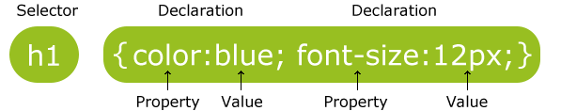

- Syntax of a CSS comment: /*This is a comment*/

1.1 Inline Style
- An inline style should be used when a single occurrence of an element has a unique style
- The inline style is put inside the elements
<h1>New Advances in Physics</h1>
<p style="margin-left: 0.5in; margin-right: 0.5in; font-style: italic">
This paper gives the solution to three previously unsolved problems: turning lead into gold, antigravity, and a practical perpetual motion machine.
</p>
<p style="color: red; margin-left: 20px">
This is a paragraph. It's colored red and indented 20px.
</p>

1.2 Internal Style
- An internal style sheet should be used when a single document has a unique style
- The internal style is put inside the <head>...</head>
- Syntax example:
<head>
<style type=”text/css”>
h1 { text-align: center;
font-family: Arial
}
h2 { color: #440000;
text-align: center;
font-family: Arial Black, Arial, Helvetica, sans-serif
}
</style>
</head>
<head>  <style type="text/css">  body {background-color: gray}  p {margin-left: 20px}  </style>  </head>  <body>  <p>The left margin is indented 20 pixels.</p>  </body> | 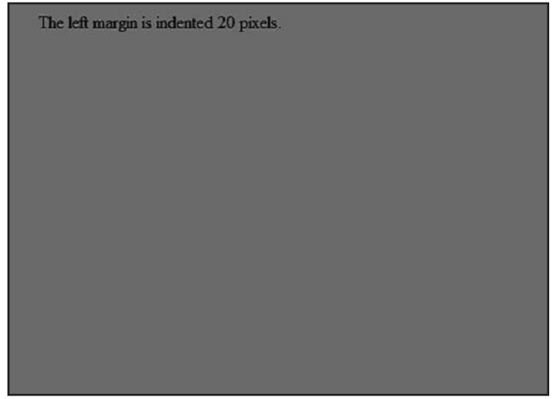

1.3 External Style
- When a specific style can be applied to many pages
- We need to target the HTML pages to the style sheet file using the syntax:
<head>
<link rel="stylesheet" type="text/css" href="mystyle.css">
</head>
- Syntax example in the style sheet file:
h1 { text-align: center;
font-family: Arial
}
h2 { color: #440000;
text-align: center;
font-family: Arial Black, Arial, Helvetica, sans-serif
}
- The External style to can use the id selector and class selector
Style Sheet File  p { margin-left: 0.5in;  margin-right: 0.5in;  font-style: italic  }  p.1 { margin-left: 0.5in;  margin-right: 0.5in;  font-style: italic  }  p.1 { margin-left: 1;  margin-right: 1;  font-style: italic  }  #para1 { text-align:center;  color:red;  } | HTML Document  <p>...</p> //Apply the p style  <p class=”1”>...</p> //Apply the p.1 style  <p class=”2”>...</p> //Apply the p.2 style  <p id=”para1”>...</p>

- The id selector is used to specify a style for a single, unique element. The id attribute is defined with a "#"
<head>
<style type="text/css">
#foo {color: red}
</style>
</head>
<body>
<p id="foo">
</body>

- The class selector is used to specify a style for a group of elements. The class attribute is defined with a "."
<head>
<style type="text/css">
.center {text-align:center;}
</style>
</head>
<body>
<h1 class="center">Center-aligned heading</h1>
<p class="center">Center-aligned paragraph.</p>
</body>

1.4 Style Sheet Rule
- The larger the number the higher the priority:
- Browser default
- External style sheet
- Internal style sheet (in the head section)
- Inline style (inside an HTML element)
- Rules marked “important” have the highest priority (rarely used)
h1 { color: black !important;
font-family: sans-serif }
- So, an inline style (inside an HTML element) has the highest priority, which means that it will override a style defined inside the <head> tag, or in an external style sheet, or in a browser (a default value)

2. References
2.1 Animation Properties
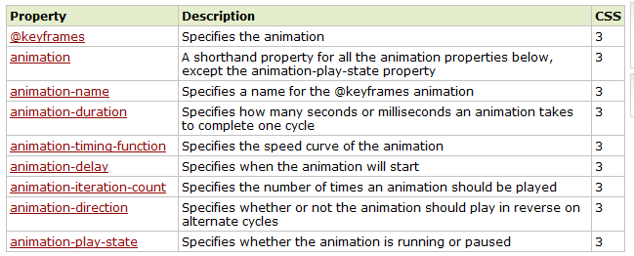

2.2 Background Properties
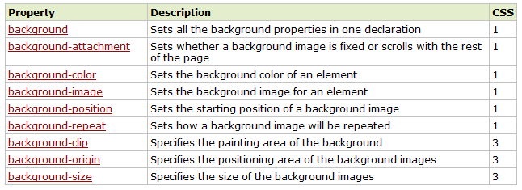

2.3 Border and Outline Properties
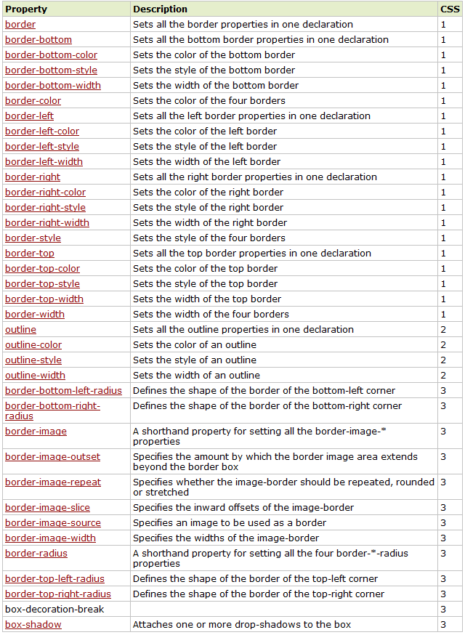

2.4 Box Properties
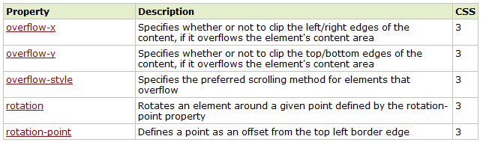

2.5 Color Properties
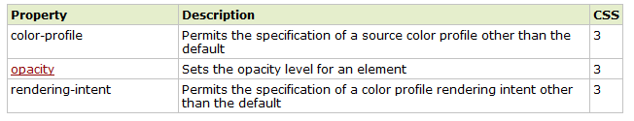

2.6 Content for Paged Media Properties
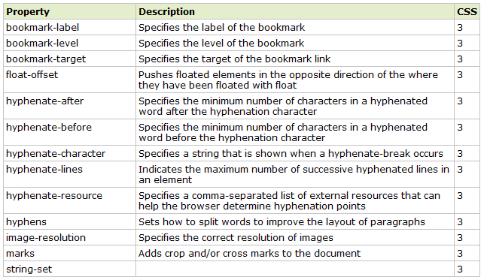

2.7 Dimension Properties
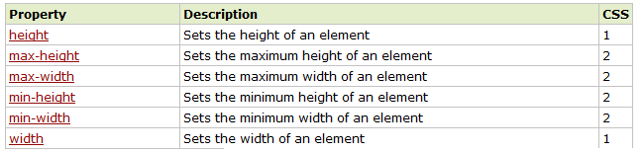

2.8 Flexible Box Properties
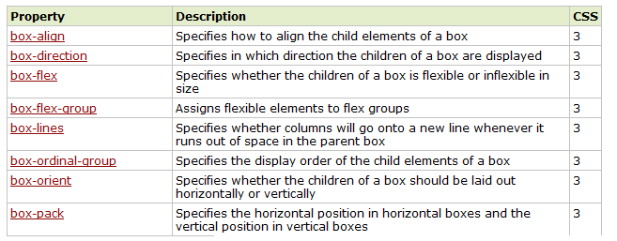

2.9 Font Properties
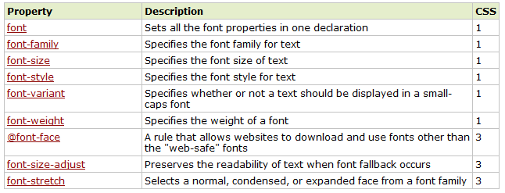

2.10 Generated Content Properties
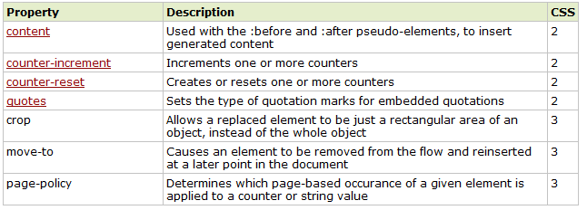

2.11 Grid Properties
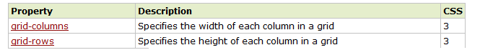

2.12 Hyperlink Properties
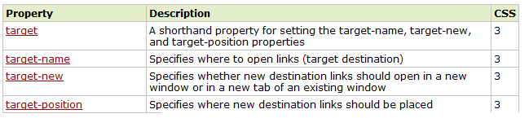

2.13 Linebox Properties
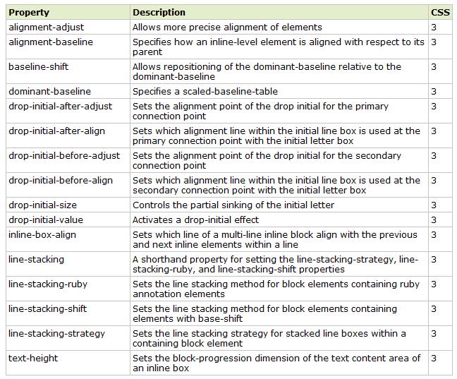

2.14 List Properties
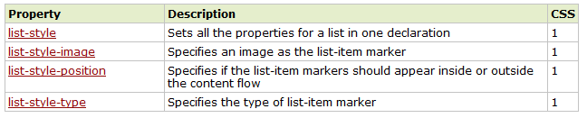

2.15 Margin Properties
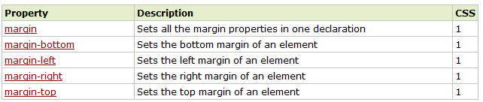

2.16 Marquee Properties
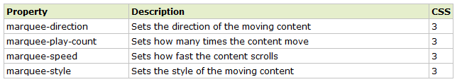

2.17 Multi-column Properties
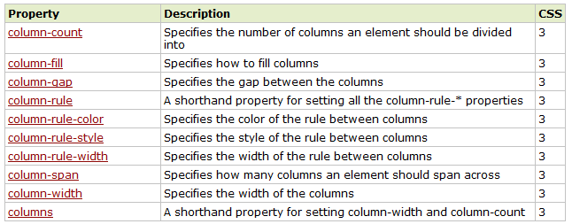

2.18 Padding Properties
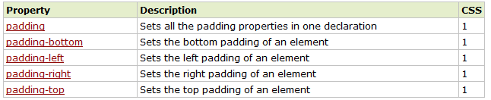

2.19 Paged Media Properties
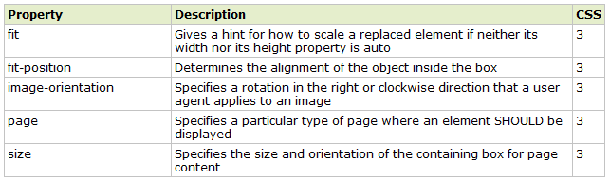

2.20 Positioning Properties
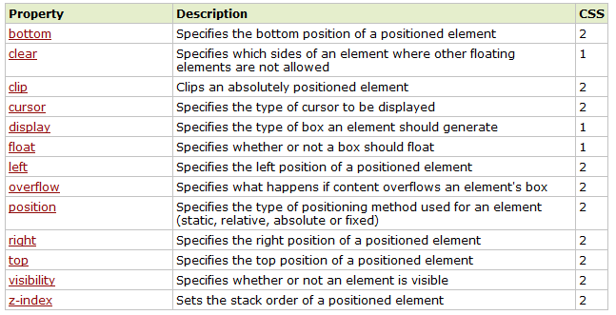

2.21 Print Properties
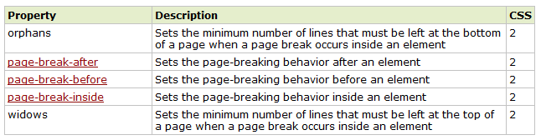

2.22 Ruby Properties
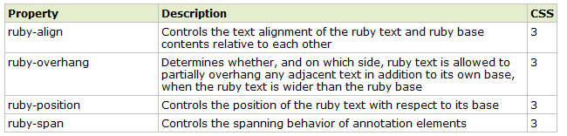

2.23 Speech Properties
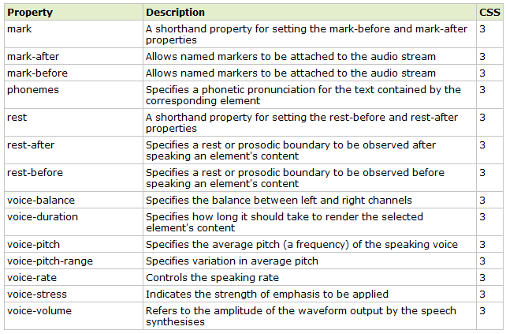

2.24 Table Properties
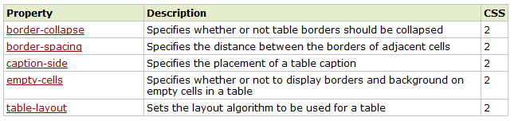

2.25 Text Properties
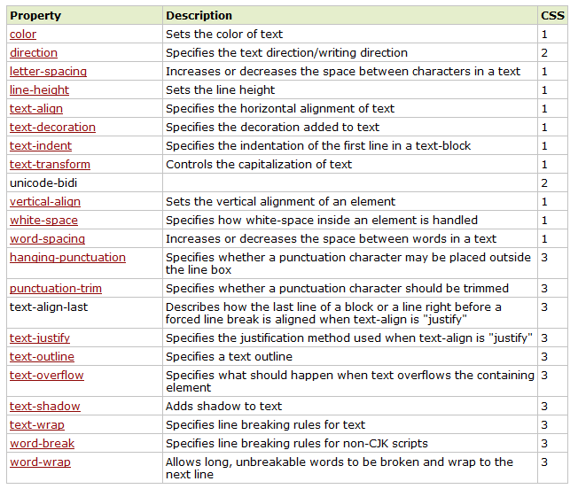

2.26 2D/3D Transform Properties
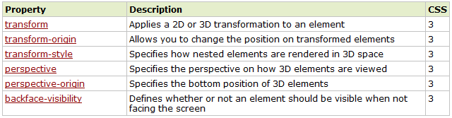

2.27 Transition Properties
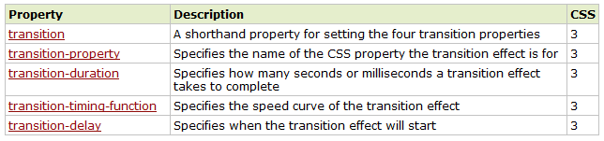

2.28 User-interface Properties
